Media Release

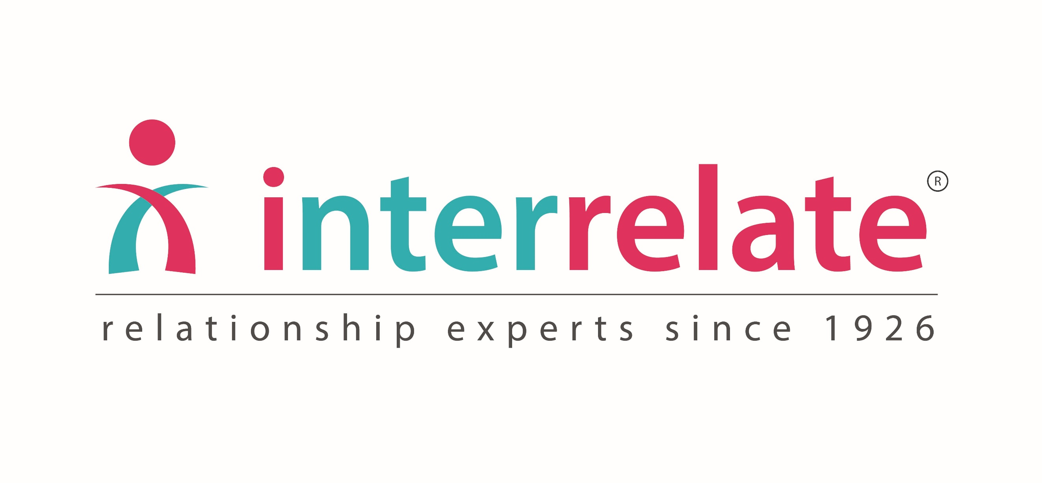

Date

Local school participating in National poster competition to recognise Australia’s diversity

Award-winning poster competition encourages children to celebrate their differences

Local school insert school name has registered for Interrelate’s 2020 Say No To Bullying Poster Competition and will be taking part on insert date. This award-winning national poster competition is heading into its 7th year with a very clear message about Australia’s vast diversity and helping children to celebrate the colourful life that our differences create.

The theme of this year’s competition is Celebrate Our Differences and Create a More Colourful World and is supported once again by Faber-Castell.

The competition is designed to help young people express their feelings through art in a supervised and safe environment.

Insert quote from Principal/teacher on importance of competition and why you are entering

The competition will coincide with the National Day of Action Against Bullying and Violence which takes place on 20th March.

“We have always seen this national day as the perfect opportunity to engage students in a constructive and collaborative exercise on the concepts of respectful relationships and treating each other with kindness and understanding,” says Patricia Occelli, CEO, Interrelate. “We’ve found over the last seven years that using art as a way to discuss and express these concepts allows the children a non-threatening approach to explore and address this ongoing issue.”

By entering the competition, students are in the running to win:
- A National Winner to receive holiday accommodation on the NSW South Coast + a large Faber-Castell gift hamper + a Faber-Castell gift pack for their class
- Major finalists each receive a Faber-Castell gift pack plus further Highly Commended prizes to be given
- All schools with a 100% participation rate will receive a full book gift set of Interrelate’s ‘Questions Kids Have’ series and go into a draw to receive Interrelate’s Bullying Awareness Program for FREE + a large Faber-Castell hamper
- All schools who register go into a draw for a large Faber-Castell hamper + a FREE webinar on a topic of your choice from Interrelate's area of expertise (puberty, bullying, resilience, diversity, cybersafety etc)
40 student finalists will also be invited to an Awards Ceremony at Government House in Sydney to be recognised in June 2020.

Schools can register now on the Interrelate website:

https://www.interrelate.org.au/get-involved/2020-poster-competition

About Interrelate
Interrelate empowers people to thrive in the most vital part of their lives – their relationships. We offer education programs, counselling services and skills development. We enable people to transform their relationships into ones that are centred on respect, and we enable people to transform their relationships. Our experienced educators empower more than 130,000 children and families through 1400 schools each year to navigate their way through bullying, puberty, sexuality and discovering healthy relationships. Interrelate has the acknowledgement of government, education and health authorities to provide relationship education in schools. You can read more about Interrelate’s relationship services for schools and families at www.interrelate.org.au

Media contact
Contact person
Your school
Phone number
Email address

Please let us know via marketing@interrelate.org.au if you get any media coverage so we can share it on our social media for you.

